**Northern University of Business and Technology Khulna**

**Department of Computer Science and Engineering**

**[Project Proposal]**

Project Title:

Unit Converter (Temperature, Length, Weight, etc.)

Submitted by:

Ratul Raha

01880-450804

ratulraha.04@gmail.com

Course Title: Software Development I

Course Code: CSE 3201

Section: 4E

Submitted to:

Shovon Madal [SM]

Lecturer,

Northern University of Business and Technology Khulna

**Date of Submission: 30 May, 2025**

Table of Contents

Project Overview: 1

Objectives: 1

Literature Review: 1

Methodology: 1

Expected Outcomes: 2

Project Timeline: 2

Resources Required: 2

References: 2

# Project Overview:

This project aims to develop a web-based Unit Converter tool that allows users to convert between different measurement units, specifically in categories such as Temperature, Length, and Weight. The problem this project solves is the need for a user-friendly, responsive, and accurate conversion tool that can be accessed via any modern browser. It will help students, engineers, and general users in day-to-day measurements and calculations without needing to install any software.

# Objectives:

* To develop a responsive and clean user interface for unit conversion.
* To allow conversions among standard units in temperature (Celsius, Fahrenheit, Kelvin), length (Meters, Kilometers, Miles, Feet), and weight (Grams, Kilograms, Pounds, Ounces).
* To use modern web technologies such as HTML, CSS, and JavaScript.
* To implement accurate mathematical logic for all conversion categories.
* To provide real-time feedback/output based on user input.

# Literature Review:

Online unit converters are commonly available, but many lack intuitive design or do not support multiple unit types in one interface. This project aims to solve this gap by offering a combined, category-wise system. Sources such as W3Schools and Mozilla Developer Network (MDN) provide technical documentation that supports web development best practices. [1]

# Methodology:

The project will use:

* **HTML** for webpage structure.
* **CSS** for layout and design.
* **JavaScript** to implement conversion logic and DOM manipulation.

A drop-down menu will let users select a conversion category. Based on the selected type, the respective units will populate dynamically. Input value and selected units will be used to calculate the result using predefined formulas. [2]

Flowchart :

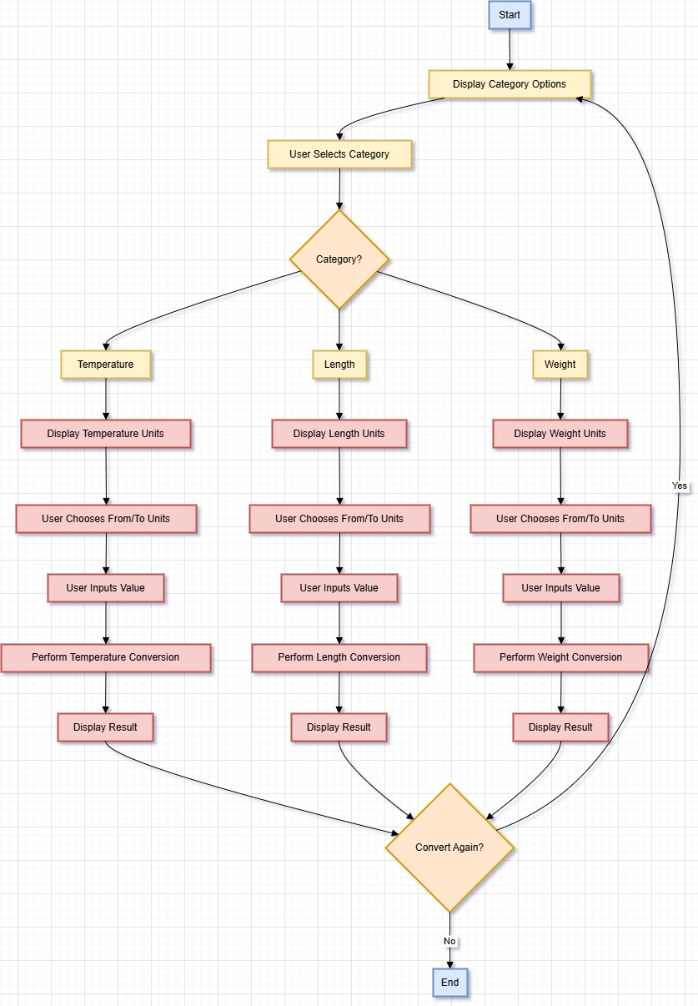

# Expected Outcomes:

* A fully functioning unit converter web application.
* Real-time, accurate conversion results.
* Responsive interface accessible via desktop and mobile devices.

# Project Timeline:

Provide a timeline for my project, including key milestones and deadlines. Helping with Gantt Chart

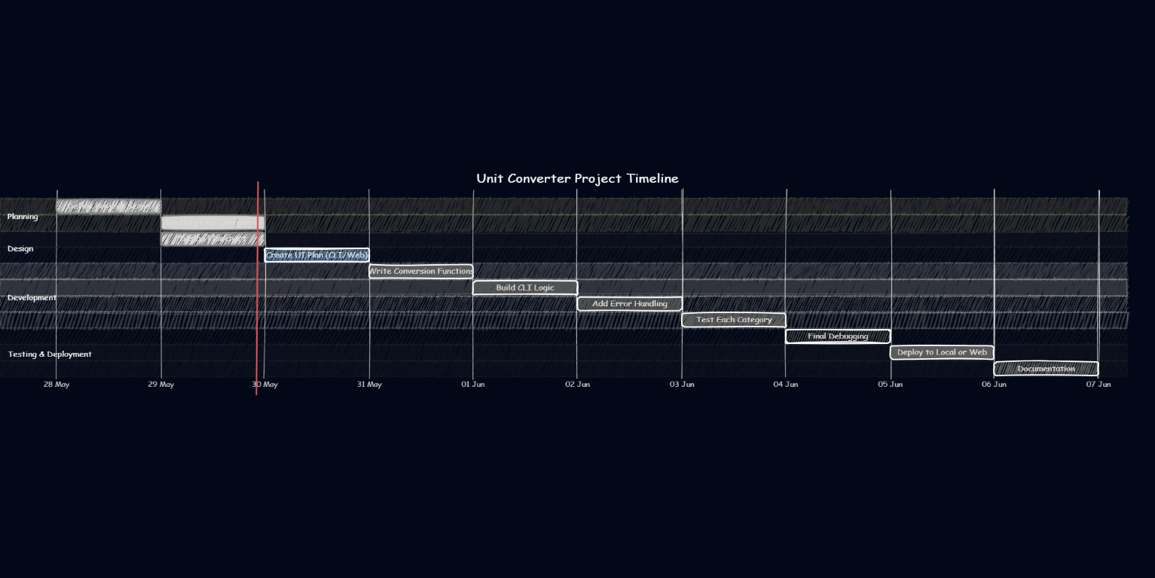

Fig. 1 : Project Timeline [1]

# Resources Required:

* A modern browser (e.g., Chrome, Firefox)
* Code Editor (e.g., VS Code)
* Reference documentation (MDN, W3Schools)

# 

# References:

* Mozilla Developer Network: <https://developer.mozilla.org/>
* W3Schools HTML/CSS/JS: https://www.w3schools.com/